17th Fairfax Civil War Day
Saturday, April 29 ★ Historic Blenheim
3610 Old Lee Hwy, Fairfax, VA 22030 ★ www.fairfaxva.gov ★ (703) 591-0560

10am – 5pm in Grandma’s Cottage

SALE AND RAFFLE*
Collectible Civil War framed art prints
by notable artists Mort Kunstler, Dale Gallon, Alan Fearnley, Tom Lovell, Don Spaulding,
and Don Stivers

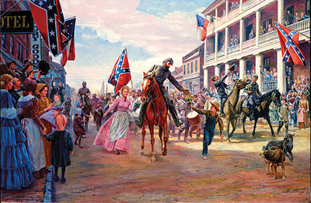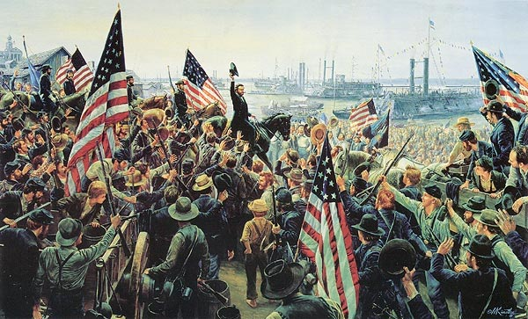

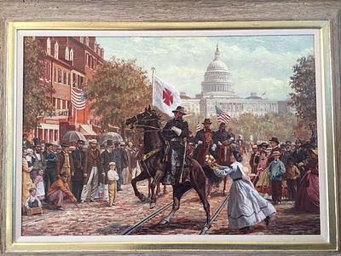

*Raffle tickets: $10 each or 3 for $25
Proceeds benefit the restoration of Historic Blenheim

